**2024 Rev. Dr. Martin Luther King Essay Contest**

**Sponsored by the Wooster-Orrville NAACP**

**Grade Categories:**

**1) *Students in grades 1st through 3rd* will be required to write an essay with a minimum of 150 words/maximum 400 words.**

2) ***Students in grades 4th through 6th* will be required to write an essay with a minimum of 400 words/maximum 700 words.**

3) ***Students in grades 7th through 9th***  **will be required to write essays with a minimum of 600 words/maximum of 900 words.**

4) ***Students in grades 10th through* 12th will be required to write essays**

**with a minimum of 900 words/maximum 1200 word*s.***

**Essay Format:**

**Required**: Each essay submitted must have a **Title** and all of the following information in the ***upper right hand corner of Page 1*:**

**Student’s First and Last Name/ Teacher’s Name/ Grade Level and School.**

We are also encouraging teachers to have students write an i*ntroduction* and *conclusion* along with the main body of the essay.

**Awards:**

**In each Category**, 1st, 2nd, and 3rd place winners will receive the following awards:

1st place: $175.00

2nd place: $150.00

3rd place: $125.00

**Due date for Essays: Friday, *December 8, 2023, 5pm.***

**\*Essays in the following school districts will be turned in as follows: Wooster SD teachers turn in essays to Wooster City Schools Board of Education Office (Diane Lepley); Orrville/Rittman SD teachers turn in essays to Superintendent Jon Ritchie’s office. *Essays from individuals and other school districts will be turned in to Trinity UCC Church office, 150 E. North St., Wooster (Rev Kevan Franklin, 330-264-9250) by 5pm December 8.***

**\*The Rev. Dr. Martin Luther King Day Celebration Service will be Monday, January 15, 2024, 7pm, at First Presbyterian Church in Wooster. The Essay Contest Award winners will be presented during that Service. We will provide updates well in advance of the Dr. King Day event.**

**\*Upon submission all essays become the property of the NAACP. All winners’ essays are kept on file indefinitely. Students are encouraged to make copies of their essays before submitting them on December 8th.**

***\*Questions? Contact Mady Noble, 330-465-4080.***

[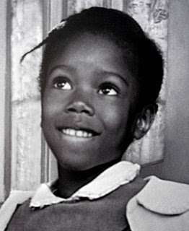](http://malomil.blogspot.com/2013/01/sem-titulo_23.html)

Ruby Bridges, 6 years old.

**Grade 1-3 Prompt**: In 1960, six-year-old Ruby Bridges became the first black child to attend the all white William Frantz Elementary School in New Orleans, Louisiana. The U.S. Supreme Court had ruled in 1954 that separate schools for black and white children would no longer be accepted but many states like Louisiana did not want that and had resisted.

1) What happened when Ruby went to Franz Elementary for the first time on November 14?

2) What was her classroom like?

3) What do you think would have been the hardest thing for Ruby going to school everyday?

4) If you could talk to Ruby about her experience many years ago, what would you say or ask?

**Resources for Teachers and Students:**

Below are student and teacher resources that may be accessed online by copying the link and pasting into a browser. *Teachers are encouraged to preview all sources* and to add other books and articles to the list.

**Robert Coles*, The Story of Ruby Bridges,* Scholastic Inc. 1995.**

**Ruby Bridges*, Ruby Bridges Goes to School,* Scholastic Inc. 2003. Excellent.**

**Online video of this book:** <https://www.google.com/search?client=safari&rls=en&q=ruby+bridges+goes+to+school+my+true+story+videos&ie=UTF-8&oe=UTF-8#fpstate=ive&vld=cid:277894b9,vid:-POfqyct9gg>

**Ruby Bridges, *I am Ruby Bridges*, Scholastic Inc., 2022. Excellent source.**

**Online video of this book:**

<https://www.youtube.com/watch?v=jWcNnHuge3I>

Disney movie, *Ruby Bridges* (1998) available for streaming on Amazon [buy] or Disney +, (1 hour, 30 minutes). *Teacher review suggested before use in the classroom.*

**Suggested Background for teachers:**

*Ruby Bridges* National Women’s History Museum (womenshistory.org)

<https://www.womenshistory.org/education-resources/biographies/ruby-bridges>

***Further historical framework for this 1960 event****:*

*The *Brown v. Board of Education* ruling, 1954 made state segregation in schools against the law but it continued throughout the South in 1960 [and much later].

*Pervasive segregation and discrimination existed for black people in stores, restaurants, parks, housing etc. and the denial of their right to vote, all of which Martin Luther King Jr. sought to end.

Included is a cropped version of Norman Rockwell’s painting of Ruby Bridges walking to school, as the original contains offensive words on the wall. She follows the U.S. Marshalls that escorted her to school each day.

[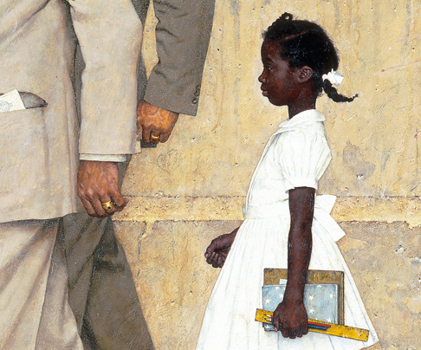](https://www.nrm.org/2013/01/norman-rockwells-civil-rights-paintings/)

**Norman Rockwell, ‘The Problem We All Live With” 1964.**

**Video** of President Barack Obama and Ruby Bridges at the White House in 2011 viewing the Rockwell painting together outside the Oval Office. President Obama praises Bridges for breaking down race barriers before him. <https://obamawhitehouse.archives.gov/blog/2011/07/15/president-obama-meets-civil-rights-icon-ruby-bridges>

**Brief Chronology of Dr. Martin Luther King and the Civil Rights Movement**

***[1929****: [January 15] Martin Luther King, Jr. born in Atlanta, Georgia.]*

**1954:** US Supreme Court rules that segregation in schools is unconstitutional *[Brown v Board of Education]*

**1955**: [August] Emmett Louis Till murdered in Money, Mississippi.

[December] Rosa Parks refuses to give up her seat on the bus to a white man in Montgomery, Alabama. Montgomery Bus Boycott begins with Dr. Martin Luther King in a leadership role.

**1957**: [September] President Dwight Eisenhower sends federal troops to Central High School in Little Rock, Arkansas, to enforce school de-segregation and protect 9 black students.

**1960**: [November] Ruby Bridges is the first black child to de-segregate a whites-only elementary school in New Orleans, Louisiana; [February] Lunch counter Sit-ins begin in Greensboro, North Carolina.

**1961**: US Supreme Court ends segregation in all interstate bus service; in May 1961 “Freedom Riders” test southern state laws that separate whites and blacks on buses and in bus stations.

**1963:** Dr. King leads Birmingham Alabama campaign to desegregate downtown stores; [May 3] police attack children with dogs and fire hoses. [Aug 28] King delivers his “I Have a Dream” speech in Washington, DC; [September] 4 children killed in church bombing in Birmingham.

**1964**: Voter education drive in the South with *Freedom Summer.* [June] 3 civil rights workers killed by the Ku Klux Klan in Philadelphia, Mississippi; [July] President Lyndon Johnson signs the *Civil Rights Act of 1964*; [August] Mississippi Freedom Democratic Party and Fannie Lou Hamer attend the National Democratic Convention in Atlantic City, New Jersey; [Dec] Dr. King awarded the Nobel Peace Prize, Oslo, Norway.

**1965**: Dr. King takes voter rights campaign to Selma, Alabama; [March 25] thousands come to Selma for the March to Montgomery demanding voting rights for black citizens; [July] Congress passes the *Voting Rights Act of 1965*.

**1967**: [April 4] Dr. King publicly opposes the Vietnam War in his *Beyond Vietnam* speech and announces a Poor People’s Campaign to end poverty.

***[1968****: [April 4] Dr. King assassinated while leading a protest in support of sanitation workers on strike in Memphis, Tennessee. He was 39 years old.]*